Lab Exercise 1- Docker Fundamental Commands

Objective
Learn and practice the fundamental Docker CLI commands to:
- Manage images and containers
- Understand container lifecycle
- Build and run applications using Docker

1. Setup
Prerequisites
- Docker installed on your system
(Check using: docker --version)
- Internet access to pull images

2. Basic Docker Commands
Step 1: Verify Installation
docker --version
docker info
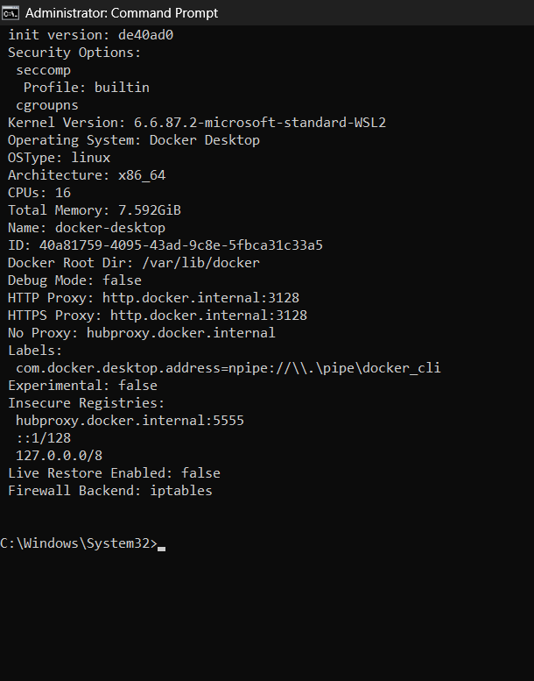
Expected Output: Docker version and system details.

Step 2: Pull an Image from Docker Hub
docker pull ubuntu:latest
Explanation: Downloads the latest Ubuntu image from Docker Hub.
Check available images:
docker images
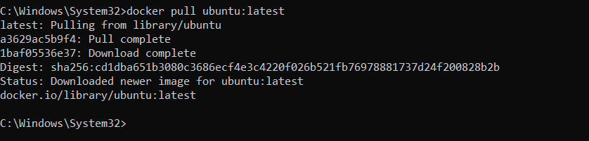
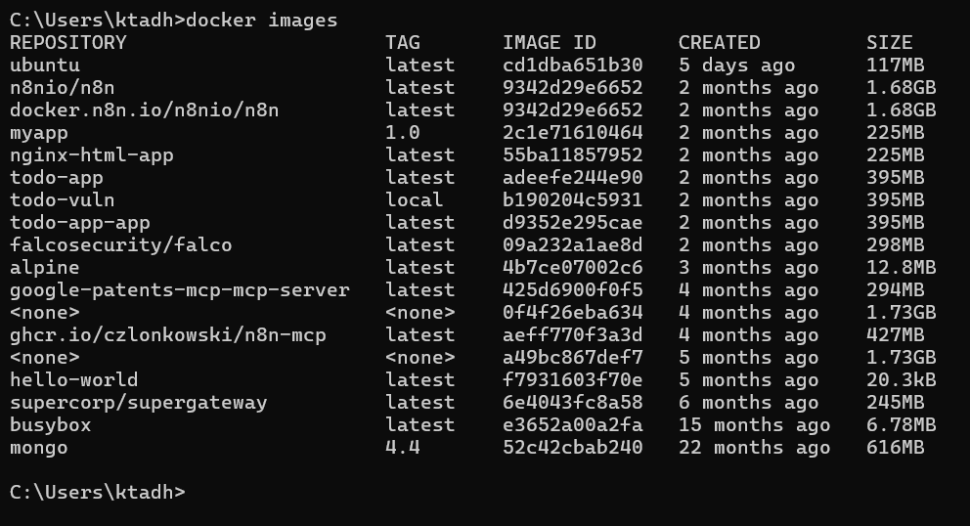

Step 3: Run a Container
Run Ubuntu interactively:
docker run -it --name myubuntu ubuntu bash
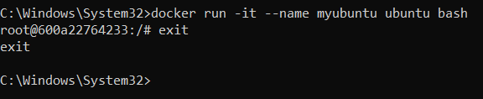

Now you’re inside a running container (prompt will change).
Exit:
Exit


Step 4: List Containers
- Show running containers:
docker ps
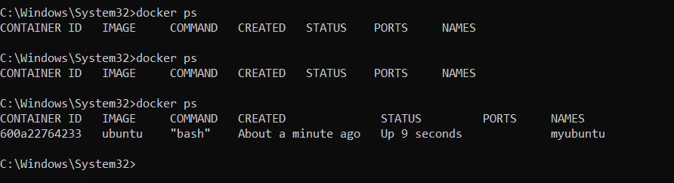
- Show all containers (including stopped):
docker ps -a
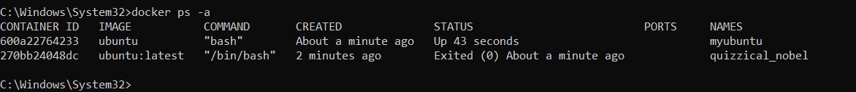

Step 5: Start / Stop / Remove Containers
# Start a stopped container
docker start <container_id>
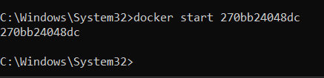
# Stop a running container
docker stop <container_id>
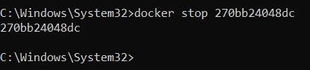
# Remove a container
docker rm <container_id>
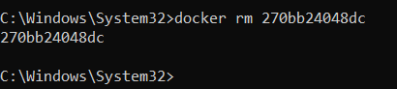
Tip: Use docker ps -a to get container IDs.

Step 6: Remove Images
docker rmi ubuntu:latest
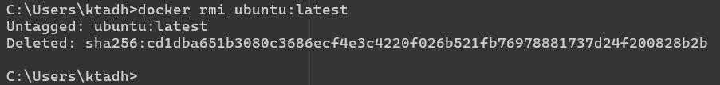
Note: You must stop and remove all containers using that image first.

